Word submission template for Advances in Geochemistry and Cosmochemistry
S. Firstauthor^{1,*}, O. Secondauthor², and A. Thirdauthor^{1,3}
¹Department of Earth Sciences, A University, City, Country
²School of Earth Sciences, Another University, City, Country
³Center for Studying Cool Things, University of X, Country
*Corresponding author: corresponding.author@mailbox.edu

Author ORCIDs
S. Firstauthor: 1111-1111-1111-1111
O. Secondauthor: 2222-2222-2222-2222
A. Thirdauthor: 3333-3333-3333-3333

Online supplementary material
https://doi.org/10.1594/IEDA/100426

Abstract
This document is the Word template for submission of manuscripts to Advances in Geochemistry and Cosmochemistry (AGC) and explains its own use. For authors who are comfortable doing so, we encourage submission in LaTeX format as this reduces pressure on our volunteer copyeditors. The general guidelines for manuscripts to be submitted to AGC can be found in the Guide for Authors.

1. Use of this template
This template has two slightly different purposes depending on what stage your manuscript is at in the publication process. At the review stage a PDF version of your article generated from this template format will be sent out for review (see Section 2). If your article (or a revised version) is accepted for publication, then this template will be used to convert it to a typeset document in LaTeX format. To use this template please replace these instructions with your own content.
Please follow the instructions in this document closely. Converting a manuscript to a typeset article is complex, with multiple ways in which things can go wrong, and is being handled by volunteer copyeditors who would rather not send more emails than necessary! Failure to comply with these instructions will likely mean that the manuscript is slowed down at the production stage and may be sent back to authors to fix.
What is particularly important for the initial conversion from Word to LaTeX format is that the structural elements of the document, such as headings, are correctly formatted using the built in styles in this document (go to Home > Styles in the ribbon in Word). Please use these styles. Using things like text size, bold or italics to indicate section headings is not sufficient and will cause problems during conversion. Please do not alter the built in styles or add new ones of your own. It is also very important that several essential sections are kept, and their headings not modified from this template (see Section 1.1 below).
Structural elements of the document which will be converted include:
- Title
- Authors, affiliations and ORCIDs
- Headings
- Italic/bold formatting
- Tables (see Section 1.4)
- Equations, incl. chemical notation (see Section 1.5)
For information about Figures see Section 1.3 below.

1.1 Essential sections
For the purposes of typesetting, it is essential that you keep the following items:
- Title
- Authors and affiliations
- Online supplementary material
- Abstract
You should of course substitute your own content but please leave the headings (other than title) unmodified from this template. If you have no ORCIDs or supplementary material to list, please leave these sections blank. For a full list of required sections see the Author Guidelines.
It is also very important that you do not include any content after the References section. This is assumed to be the last section of the manuscript and content after this will be automatically ignored during typesetting. Sections such as Acknowledgements, Data and Code Availability Statement, Author Contributions (CRediT) Statement, as well as figure and table captions (e.g. if figures/tables are not embedded) should be placed after the conclusions and before the references.

1.2 Title and headings
It is important that title and headings are correctly formatted using the relevant formats as used in this document (Title, Heading 1, Heading 2 etc.). Accidental formatting of other elements (e.g. figures) as one of these headings is a common source of problems in the conversion process. Please give each section a number as this greatly aids cross-referencing and do not use more than three levels of headings (i.e. 1.1.1 etc.).
Basic formatting like bold and italics will be preserved, as will superscript and subscript.
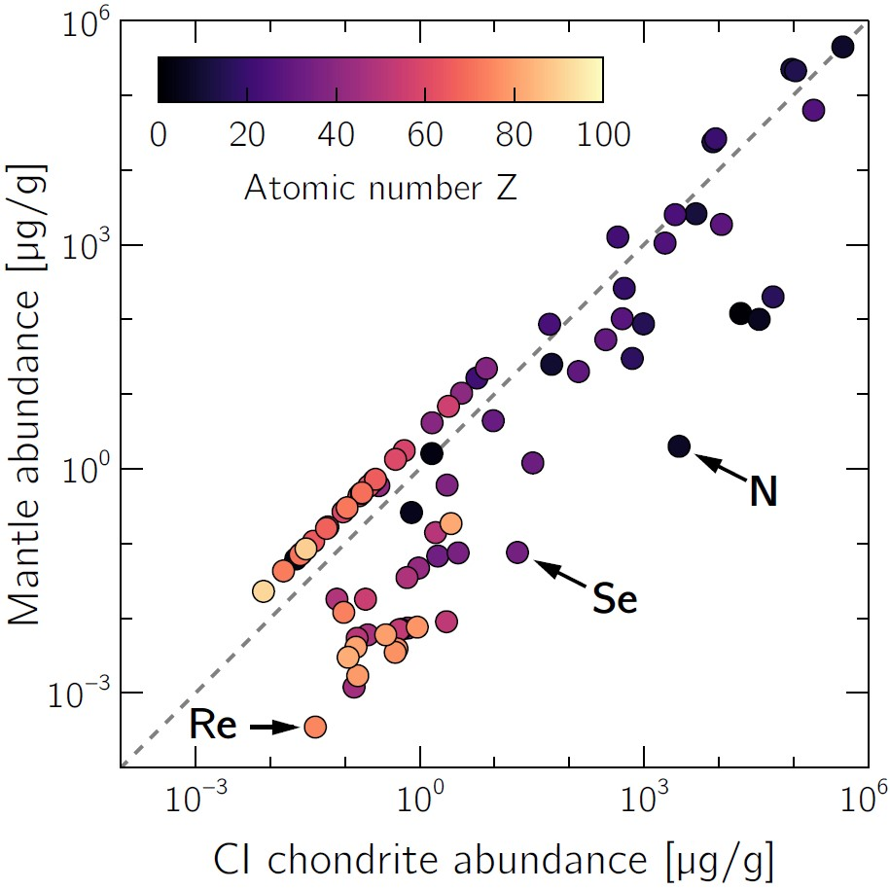
Figure 1: Comparison of elemental abundance between Earth's mantle and CI chondrite (Palme, H. and O’Neill, H., 2014). Figure captions should begin “Figure X:” in bold, where X is the figure number, and should be formatted using the Fig_Tab_Caption style.

1.3 Figures
Figures can be embedded within the document for initial submission and review. For copyediting of accepted articles, figures will also need to be provided as separate files (although they can still be embedded within the document to indicate their position). Figure captions should immediately follow the figure. They should begin “Figure X:” in bold, where X is the figure number, and should be formatted using the Fig_Tab_Caption style as shown for Figure 1.
If figures are not embedded within the manuscript file, please list the captions before the references with formatting as above.

1.3.1 Figure formats
Figures for typesetting can be submitted in various formats. For best results, we suggest using PDF (.pdf) for vector graphics and TIFF (.tif) for pixel graphics. When using PDF format, all fonts must be embedded. If and only if certain fonts cannot be embedded for some reason, the respective glyphs must be converted to paths before the graphic is included in the manuscript. Be aware that this can significantly slow down rendering of the resulting PDF, which is annoying to readers on less powerful hardware. In extreme cases, the copyediting team may convert overly complex vector graphics into pixel graphics to speed up rendering.

1.4 Tables
The best design for a table is largely dictated by the content of the table. Therefore, AGC does not impose specific design rules apart from those detailed in the Author Guidelines. All tables must be accompanied by a caption, immediately above the table in question, which should begin “Table X:” in bold, where X is the table number, and should be formatted using the Fig_Tab_Caption style as shown below.
At submission, tables should be included within the text using the native Word table editor function.
For typesetting an accepted article, tables are a common source of issues and we therefore ask that you also submit all tables as separate files in .csv format. Small tables (e.g., Table 1) and tables which primarily contain text may be converted directly from the Word document. Nonetheless it is advisable to submit a separate version as a .csv in case of issues with the conversion.
Table 1: Chemical analyses and formulas of some minerals. Table captions should begin “Table X:” in bold, where X is the table number, and should be formatted using the Fig_Tab_Caption style.
Mineral | Kfs | Ms | Qz
Formula | KAlSi₃O₈ | KAl₃Si₃O₁₀(OH)₂ | SiO₂
SiO₂ [wt%] | 64.76 | 45.25 | 100.00
Al₂O₃ [wt%] | 18.32 | 38.40 | 0.0
K₂O [wt%] | 16.92 | 11.82 | 0.0
H₂O [wt%] | 0.0 | 4.52 | 0.0

Larger tables, or those with complex formatting such as merged cells, will likely require manual typesetting. Along with a .csv of the data please also supply a formatted PDF or .xlsx version of such tables to guide the copyeditor in how to typeset these. This will minimise the amount of back and forth, saving everyone’s time and speeding up the copyediting process.

1.5 Equations
Equations should be formatted using the built in Word equation editor. The typesetting of mathematical expressions and equations is a major source of errors. We strongly encourage submitting any manuscripts that are heavy on equations in LaTeX format to avoid errors stemming from format conversion. Irrespective of the chosen submission format, authors should always double check that all equations are rendered correctly in the PDF files for submission and pay special attention to equations during correction of the final proofs. If appropriate, equations can be typeset in-line (e.g., $a^{2}+ b^{2}= c^{2}$).
Short referenceable equations, such as Bragg's law will normally be typeset in a single column:
$$nλ = 2d sin θ$$
Equations can also be more than one line long, like so:
$$ΔS = S_{T2} - S_{T1}$$
$$=\int_{T1}^{T2}{\frac{C_{p}}{T}}dT$$
$$=\int_{T1}^{T2}{C_{p} d\ln{T}}$$

1.5.1 Chemical formulas
Chemical formulas, including isotopes (e.g., ¹⁸O, ⁸⁷Sr/⁸⁶Sr) and molecular species (e.g., SiO₂, CO₃²⁻) should be formatted using superscript and subscript as appropriate. This will help to parse these expressions for typesetting. This is a potential source of error during typesetting and should be checked carefully at proof stage to ensure there are no problems.

1.7 Hyperlinks and internal references
We advise using Word’s native hyperlink functionality to refer internally to other sections (Insert > Link > Place in This Document). Use of both a numerical and descriptive identifier (e.g., see Section 3 - Methods) is advised to avoid ambiguity. This will greatly aid identifying these internal references and converting them into clickable hyperlinks in the final typeset document.
Hyperlinks to external material should be avoided as this is not an appropriate form of referencing. These will be stripped during conversion. All supporting references (including URLs if appropriate) should be given in APA style and listed in the References section (see Author Guidelines).

1.8 Bibliography
Please include a list of all references cited in the manuscript. DOIs for the references cited must be provided when they are available, the full author list must be included and all entries must be in Latin script (aka. Roman script). Please use the author-date APA reference style: Author (Year) or (Author, Year) for in-text citations. Note that Advances in Geochemistry and Cosmochemistry discourages citing "personal communications" or references to articles "in prep" or "submitted". Preprints and other non-peer reviewed material may be cited where appropriate, as long as they are publicly accessible. Please contact your handling editor for any questions regarding references to non-peer-reviewed material.

1.9 Supplementary Materials
Please provide the web address of all data, code, and outputs published at an external repository under the heading Online Supplementary Materials immediately before the abstract. This can be a private link to a data repository for the purpose of the review process but must be a valid DOI for the final submission. If there is no material in an external repository, simply leave this section blank.

2. Submission

2.1 Initial (or revised) submissions for review
For initial submission please embed all images and their captions within this document, tables should be formatted using the built in Word table functionality.
Prior to submission for review it is advisable to save the document as a PDF (.pdf) and check that its appearance is what you expect. The online submission portal will allow upload of a .docx file and will automatically convert it to a PDF but unexpected changes of formatting could occur.

2.1.1 Files to submit for review
- Manuscript document – saved as a single PDF
  - all figures, tables and captions embedded
- Any supplementary materials (text or figures) – saved as a separate single PDF file
Note: any supporting data and code should be archived in an external, online repository (see data, code, and outputs availability policy).

2.2 Submission of accepted articles for typesetting
For typesetting an accepted article, the copyediting team will need your manuscript in this template along with separate files for any figures and tables (see Sections 1.2 and 1.3 above). Please DO NOT save this template as a PDF for this final submission as this will not be usable by the conversion software.

2.2.1 Files to submit for typesetting
- Manuscript – in this template saved as .docx
  - Text, simple tables and all figure/table captions (a copy of figures can be embedded to indicate their preferred position)
- Separate files for all images (.tiff or .pdf preferred)
- Separate .csv files for all tables
- Formatted .pdf or .xlsx files for any complex tables (to guide typesetting)
- Any supplementary text or figures saved as a single PDF file

Licence agreement
By submitting an article to Advances in Geochemistry and Cosmochemistry, the authors agree that their article will, upon acceptance for publication, be distributed under the Creative Commons Attribution 4.0 International licence (CC BY 4.0), with copyright retained by authors by default. Articles will generally contain the following statement after the Acknowledgements and before the References:
This article is distributed under the terms of the Creative Commons Attribution 4.0 International Licence (CC BY 4.0), which permits unrestricted use, distribution, and reproduction in any medium, provided appropriate credit is given to the original author(s) and source, as well as a link to the Creative Commons licence, and an indication of changes that were made.
Should any author(s) require that the published article deviate from the above (e.g. copyright needs to reside with your employer or an alternative licence is required - e.g. authors who are Crown employees), you must add this request to your cover letter to the editor. The submitting author is responsible for requesting (and following up) this deviation from the standard licensing agreement. All deviations from the above must be agreed in writing as early as possible in the submission process and must be in place before the article is sent for typesetting.

References
Palme, H. and O’Neill, H. (2014). Cosmochemical Estimates of Mantle Composition. In Treatise on Geochemistry. Elsevier, 1–39, doi:10.1016/B978-0-08-095975-7.00201-1.

Please DO NOT include any content after the references! It will not get converted.

